**Reviewing Assignment**

Assignment 5

|  |  |
| --- | --- |
| Started: | Oct 27, 2014 6:38 PM |
| Finished: | Oct 27, 2014 11:06 PM |

 1 of 1

**Assignment 5     Total Grade: 70   (of possible 70 points)**

This assignment has two parts.

In part 1, you need to submit an **html source file** and a **JavaScript file**.

Part 2 has 5 multiple choice questions.

All the files you need for this assignment are available under Resources.

**Part 1 of 2  Happy Halloween!     Score: 35   (of possible 35 points)**

**Question 1 of 6     Score: 35   (of possible 35 points)**

Your task this week is to animate a halloween themed web page.

Download the html document halloween.html from Resources and save it in an html directory on your computer.

Download the image files pumpkinon.gif (a lit jack-o-lantern) and pumpkinoff.gif (a dark jack-o-lantern) from Resources and save them in the same html directory.

Open halloween.html in Firefox and make sure the image displays correctly.  You should see a pumpkin.

Your task is to **write a JavaScript program spooky.js** that changes the image in the document every 3 seconds.

The image changes from pumpkinoff.gif to pumpkinon.gif, back to pumpkinoff.gif and so on every 3 seconds.

**Modify the html file halloween.html by adding a <script> tag**pointing to **spooky.js**. **The JavaScript file has to be saved in a separate scripts directory with the same parent directory as html.**  For example you may have your files as:

CS22A/html/halloween.html and CS22A/scripts/spooky.js.

Make sure that you use **relative path names**so that I can open the web page and use it on my computer.

The screencast below shows the web page in the browser after you have implemented the changes above.

 https://www.youtube.com/watch?v=4Uqbqp-jXSQ

To submit your solution, upload **the modified halloween.html file and your new spooky.js file.**

HINTS:

This assignment is based on modules **8** and 9.

1.  The setInterval() method introduced in module 8.4 may be used to call a function repeatedly.

2.  Your web page has to toggle between the pumpkinon and the pumpkinoff image.

3.  It is OK to keep track of the current image by using a global variable.

4.  Module 9.13 includes an example on how to change an image in a web page.

5.  **Make sure you have the Firebug console open when you are testing so that you can see error messages generated by the program**.

**Answer**

* text/html[halloween.html](https://myetudes.org/access/mneme/content/private/mneme/09ae2205-2717-4bfc-00cf-33f5bdcd7b48/submissions/14976526/3729486e-770d-4014-0082-e0a98bbc7544/halloween.html)
* text/javascript[spooky.js](https://myetudes.org/access/mneme/content/private/mneme/09ae2205-2717-4bfc-00cf-33f5bdcd7b48/submissions/14976526/012bc672-9abb-45a8-00dd-94fb9ce76ca1/spooky.js)

[[https://myetudes.org/ambrosia_library/icons/expand.gif](https://myetudes.org/portal/tool/acd42055-9bd4-4630-8071-c0425c2388c3/review/14976526/list) Model Answer](https://myetudes.org/portal/tool/acd42055-9bd4-4630-8071-c0425c2388c3/review/14976526/list)

**Comments**

Good work!

**Part 2 of 2  A Personalized Web Page     Score: 35   (of possible 35 points)**

All questions in part 2 are based on the html source file assign.html.

This file is available under Resources.

Try to answer the questions without using the JavaScript interpreter first to check your understanding.

You should verify your answer with the interpreter when you think you’ve got it.

You may need to **reload the html file before each question** so that the changes that you make in one question do not affect the subsequent ones.

**Question 2 of 6     Score: 7   (of possible 7 points)**

How can I change the heading from "Today's Lesson" to "Alice's Lesson" without changing anything else on the page?

|  |  |  |
| --- | --- | --- |
|  | A. | document.getElementById('lesson').innerHTML  = "Alice's Lesson"; |
| Correct | B. | document.getElementsByTagName('h2')[0].textContent = "Alice's Lesson"; |
|  | C. | document.body.getElementById('lesson').firstElementChild.textContent = "Alice's Lesson"; |
|  | D. | document.getElementById("lesson").firstElementChild.value   = "Alice's Lesson"; |
|  | E. | I can’t because that heading has no id. |
|  | F. | document.getElementById('lesson').firstChild.textContent = "Alice's Lesson"; |

 Answer Key: B

**Feedback**

document.getElementsByTagName("h2") returns an array like object.  To access one element, we  need to index it: document.getElementsByTagName("h2")[0].textContent = "Alice's Lesson";

Here's why some of the other choices are not valid:

document.getElementById("lesson").firstChild gives us a text node that contains the extra new line character.

getElementById() is only defined on the document object.  It will not work on document.body.

We need to get to: document.getElementById("lesson").first**Element**Child to get to the <h2> element.

document.getElementById("lesson").innerHTML  = "Alice's Lesson" would change a lot more than we want to in the page.

The value property is not defined for the <h2> element.

**Question 3 of 6     Score: 7   (of possible 7 points)**

How do I change the text under Element Selection to 'Completed'?

I would like the web page to look as follows:

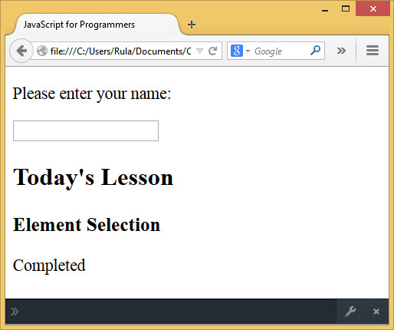

|  |  |  |
| --- | --- | --- |
|  | A. | document.body.innerHTML = 'Completed'; |
|  | B. | document.body.getElementsByTagName('p')[2].textContent = 'Completed'; |
|  | C. | document.body.lastElementChild.textContent = 'Completed'; |
|  | D. | document.getElementById('lesson').textContent = 'Completed'; |
| Correct | E. | document.getElementById('lesson').lastElementChild.textContent = 'Completed'; |

 Answer Key: E

**Question 4 of 6     Score: 7   (of possible 7 points)**

How do I get the 'important' text only and assign it to the variable summary?

After the assignment, I would like the variable summary to hold the following string:

>>> summary

"The recommended method is the simplest one: getElementById().The value of the id attribute must be unique within the document."

|  |  |  |
| --- | --- | --- |
|  | A. | var summary = document.getElementById('lesson').getElementsByTagName('p')[0].textContent; |
|  | B. | var summary = document.getElementsByClassName('important').textContent; |
|  | C. | var summary  = document.getElementsByTagName('span').innerHTML; |
| Correct | D. | var summary = document.getElementsByClassName('important')[0].textContent + document.getElementsByClassName('important')[1].textContent; |

 Answer Key: D

**Question 5 of 6     Score: 7   (of possible 7 points)**

How do I get the name entered by the user?

|  |  |  |
| --- | --- | --- |
|  | A. | document.getElementById('text').value; |
| Correct | B. | document.getElementById('profile').value; |
|  | C. | document.body.getElementById('profile').innerHTML; |
|  | D. | document.getElementById('name').textContent; |
|  | E. | document.getElementById('profile').textContent; |
|  | F. | document.getElementById('name').value; |

 Answer Key: B

**Feedback**

For user input, we need to use the value property.

To get to the input element, we use document.getElementById('profile')

Note that getElementById() is only defined on the document object.  It will not work on document.body.

**Question 6 of 6     Score: 7   (of possible 7 points)**

How do I replace the top part (only) with:  Hello Alice!

I would like the page to look as follows (when in a smaller size window):

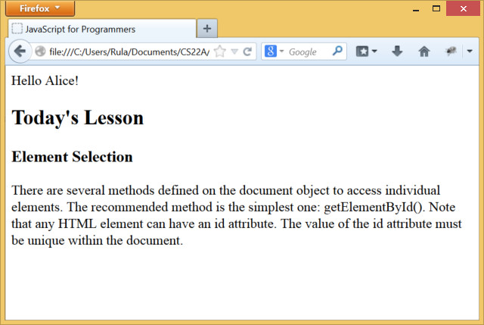

|  |  |  |
| --- | --- | --- |
|  | A. | document.getElementById('name').value = 'Hello Alice!'; |
|  | B. | document.body.getElementsByClassName('p').textContent  = 'Hello Alice!'; |
|  | C. | document.getElementsByTagName('p').innerHTML  = 'Hello Alice!'; |
|  | D. | document.getElementById('profile').textContent = 'Hello Alice!'; |
| Correct | E. | document.getElementById('name').textContent = 'Hello Alice!'; |

 Answer Key: E

 1 of 1